**PROBLEM SOLVING USING COMPUTERS**

**Lab 1. Sequential Instruction Based C Programs**

1. Program to print “Hello” on the Screen.

1. Write a program to take an input of two integer numbers and print the sum of that numbers.

1. Convert the time in seconds to hours, minutes and seconds. (1 hr =3600 sec).

1. Find the sum of the digits of a four-digit number (ex 1234 sum=10) (without using a loop).

1. Convert temperature given in Fahrenheit to Centigrade and Centigrade to Fahrenheit. Hint: C=5/9(F-32)).

1. Converting distance in mm to cm, inch, feet (1 cm =10mm, 1inch=2.5cm, 1 feet =12 inches).

1. Find out the distance between two points e.g. (x1, y1) and (x2, y2).

Hint: Distance=√(x2-x1)2+ (y2-y1)2

1. Evaluate the area of the circle Area = Pi * R2

1. Interchange values of two variables using a third variable.

1. Interchange values of two variables without using a third variable.

**Lab 2. Control Structures: If, If-Else and Switch-Case statements**

1. Check whether the given number is odd or even.

1. Check whether a given year is a leap year or not.

1. Write a program to take two numbers as an input and find whether one number is multiple of other or not.

1. Write a program that returns a letter grade based on a quiz score. The input will be the integer score from a ten-point quiz.
   1. The letter grades are assigned by:
   2. 9 – 10 “A” 7 – 8 “B” 5 – 6 “C” 3 – 4 “D” < 3 “F”

1. Write a program to check whether given character is vowel, consonant or digit.

**Control Structures: Switch-Case**

1. Program to calculate an area of a circle, a rectangle or a triangle depending on user’s choice.

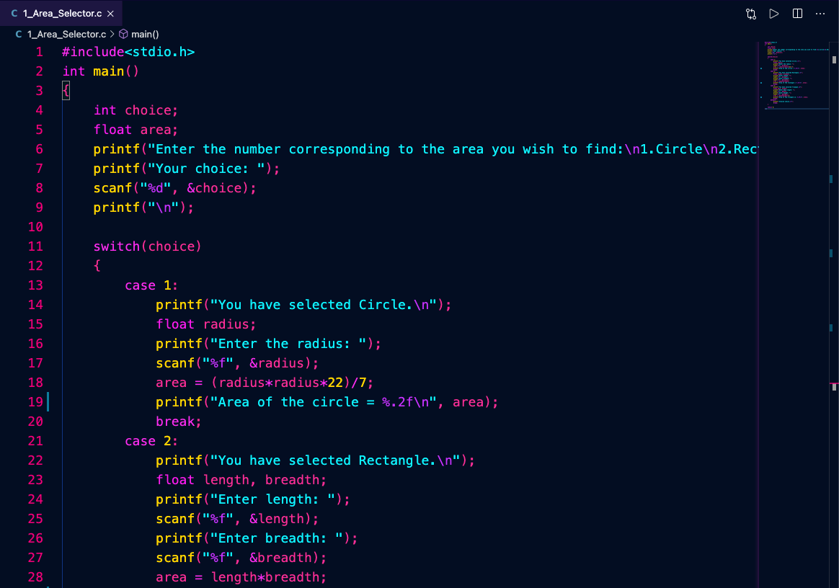

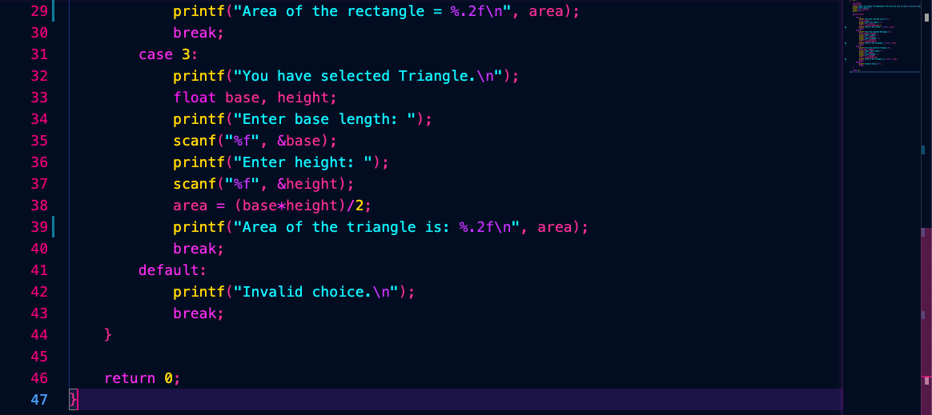

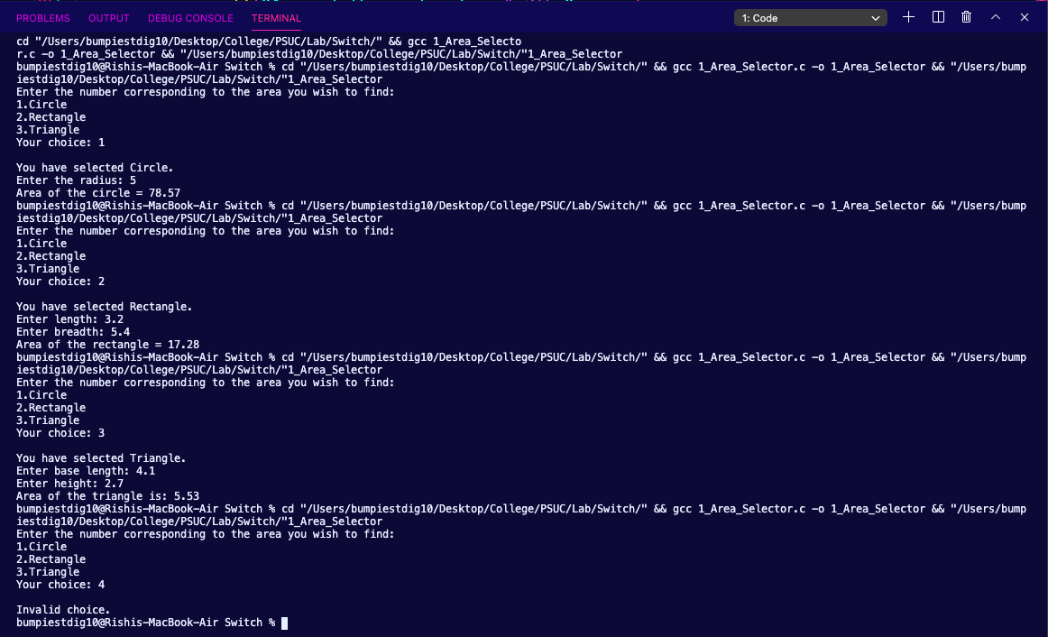

1. Write a program to design a calculator that performs addition, subtraction, minus and division operation. This program inputs two operands and an operator and then displays the calculated results.

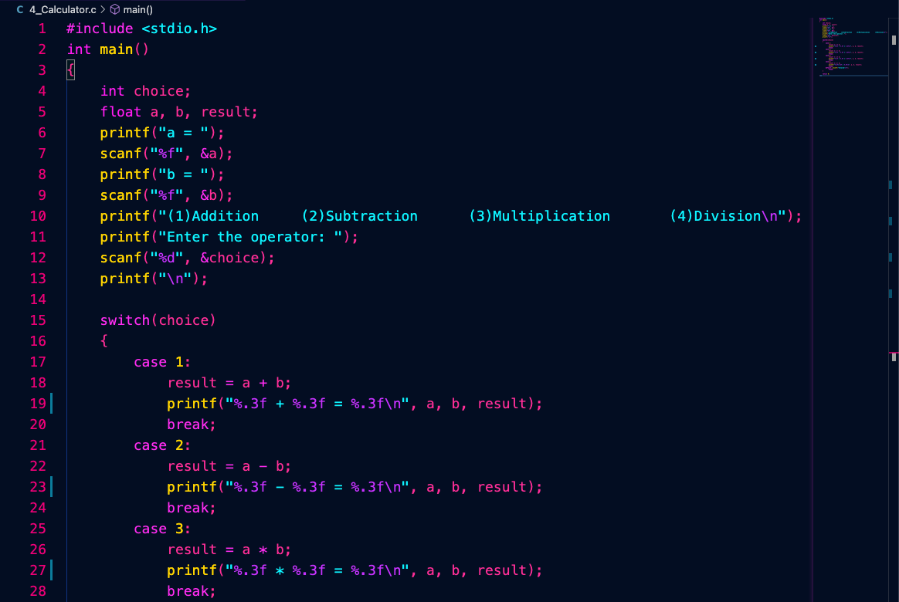

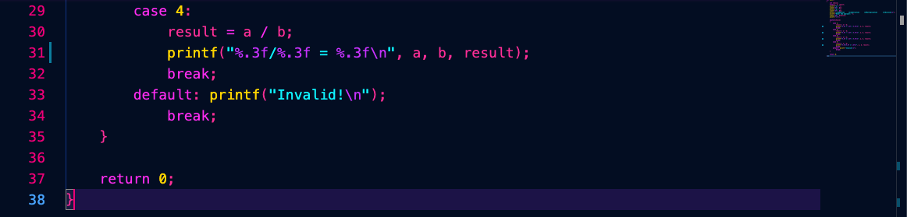

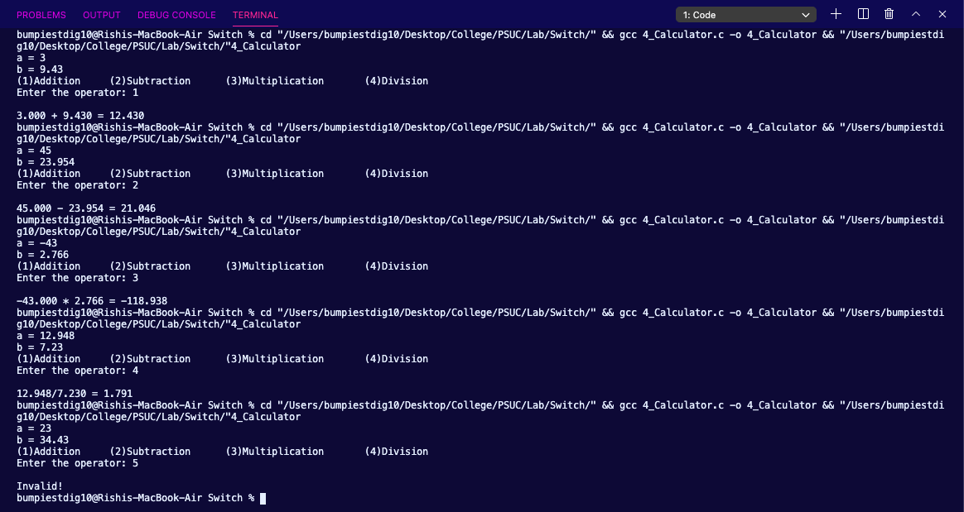

1. Write a program to calculate a bill of internet browsing. The conditions are given below:

Minimum Rs. 200 for up to 100 calls

Plus, Rs. 0.60 per call for next 50 calls.

Plus, Rs. 0.50 per call for next 50 calls.

Plus, Rs. 0.40 per call for any call beyond 200 calls

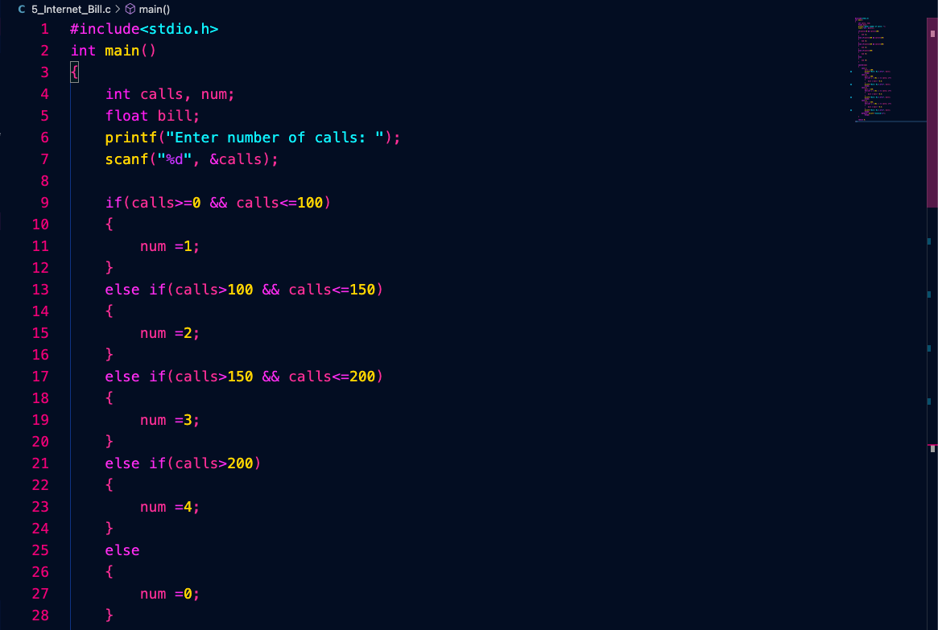

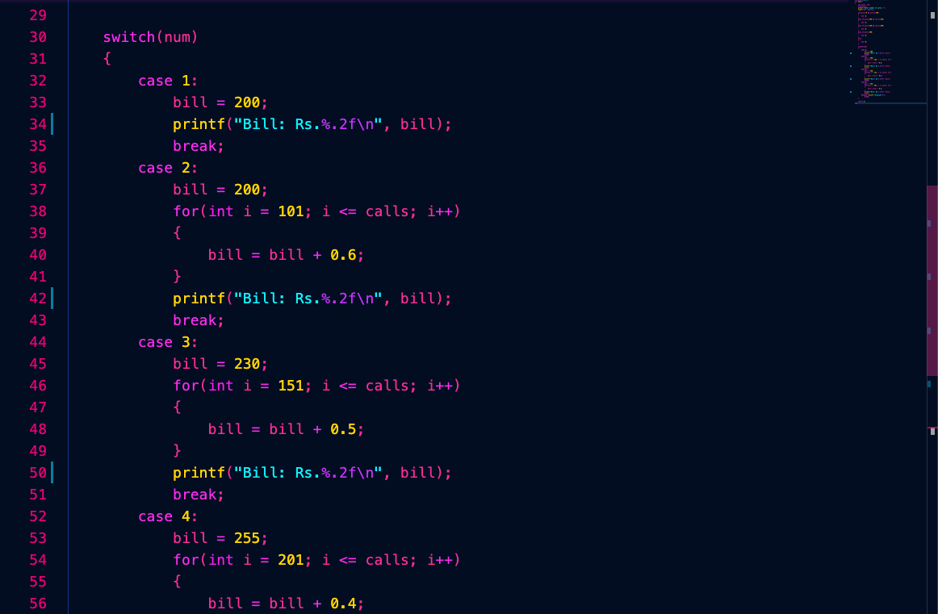

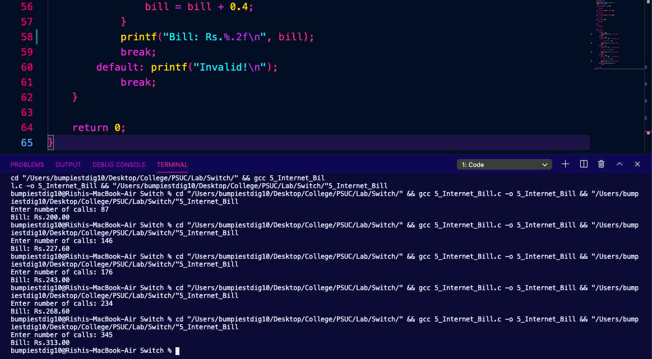

**Lab 3. Control Structures: Loops and Nested Loops**